**FRONT END ENGINEERING-II**

Project Report

Semester-IV(Batch-2022)

**Template Clone**

**Supervised By: Submitted By:**

Mr. Raveesh Samkaria Swastik Verma

2210990882(G13)

**Department of Computer Science and Engineering**

**Chitkara University Institute of Engineering & Technology, Chitkara University, Punjab**

**Abstract**

**Yoopin** is an innovative web platform designed to deliver high-quality work at affordable prices, leveraging cutting-edge technologies like Vite, React, HTML, CSS, and Bootstrap. Our goal is to provide users with an efficient and user-friendly experience, ensuring that each project meets the highest standards of excellence while remaining budget-friendly.

Our mission is to bridge the gap between quality and affordability in the digital landscape. We are committed to delivering exceptional work that not only meets but exceeds our clients' expectations, all while maintaining a cost-effective approach.

It stands out as a reliable and innovative platform for those seeking quality work at reasonable prices. By integrating state-of-the-art technologies and maintaining a strong focus on user satisfaction, Yoopin is set to redefine standards in web development and design services.

**Table Of Content**

|  |  |  |
| --- | --- | --- |
| **Sr No.** | **Section** | **Page No.** |
| **1.** | Introduction | 4 |
| **2.** | Problem Statement | 6 |
| **3.** | Technical Details and  Template design | 7 - 8 |
| **4.** | File Structure | 9 |
| **5.** | Code | 10 |
| **6.** | Result and References | 15 - 20 |

**1.Introduction**

In today's digital age, the demand for high-quality web development and design services has never been greater. As businesses and individuals seek to establish a robust online presence, the challenge often lies in finding a balance between quality and affordability. An innovative web platform committed to delivering top-notch work without breaking the bank. By leveraging the latest technologies, including Vite, React, HTML, CSS, and Bootstrap, ensures that each project is crafted to perfection, offering clients a seamless and budget-friendly experience.

**1.1) Background--**

In today's fast-paced digital landscape, having a strong online presence is essential for businesses and individuals alike. Websites are no longer just digital brochures; they are dynamic, interactive platforms that can engage customers, drive sales, and build brand loyalty. However, the process of creating and maintaining a high-quality website often comes with significant costs, which can be prohibitive for many small businesses and individuals.

Recognizing this challenge, our innovative web platform was established to bridge the gap between high-quality web development and affordability. We understand that every business, regardless of its size, deserves a professional online presence. By utilizing modern technologies and optimizing our workflows, we aim to make top-notch web development accessible to everyone.

**1.2) Objectives--**

Our platform is built on a foundation of clear objectives designed to meet the needs of our diverse client base:

Deliver High-Quality Web Development and Design:

Technology Stack: We leverage the latest technologies, including Vite, React, HTML, CSS, and Bootstrap, to ensure that our projects are not only visually appealing but also highly functional and efficient.

Customization: Each project is tailored to the specific needs of the client, ensuring a unique and personalized web presence.

Maintain Affordability:

Cost-Effective Solutions: By optimizing our workflows and utilizing cost-effective technologies, we are able to reduce overhead costs. This allows us to offer competitive pricing without compromising on quality.

Accessibility: Our commitment to affordability ensures that high-quality web development services are accessible to businesses and individuals with varying budgets.

Provide Exceptional Client Experience:

Seamless Process: From initial consultation to final delivery, our process is designed to be smooth and hassle-free. We prioritize clear communication and transparency at every stage.

Ongoing Support: We offer ongoing support and maintenance services to ensure that our clients' websites remain up-to-date and perform optimally over time.

**2.Problem Statement**

In today’s digital age, establishing a robust online presence is crucial for businesses and individuals alike. However, this often presents a significant challenge, primarily due to the high costs associated with quality web development. Traditional web development services are typically expensive, making them inaccessible to small businesses and individuals with limited budgets. This creates a disparity where only well-funded entities can afford top-tier websites, leaving others to settle for subpar solutions or do-it-yourself options that lack professionalism and effectiveness. On the other end of the spectrum, affordable alternatives often compromise on quality. These cheaper solutions frequently result in poorly designed, non-responsive websites that fail to engage users effectively. Such compromises can harm the credibility and growth potential of a business, as the website may not meet the functional and aesthetic standards required to make a positive impression on visitors.

The use of HTML and CSS ensures that websites are structurally sound and visually consistent across different platforms, while Bootstrap’s comprehensive library of pre-styled components and grid system allows for the development of responsive, mobile-first designs. This combination of technologies ensures that Yoopin can deliver high-quality websites that meet the latest standards and best practices. Yoopin also places a strong emphasis on user experience, creating websites that are intuitive, fast-loading, and accessible across all devices. Rigorous quality assurance processes are employed to ensure that every aspect of the website meets high standards, including thorough testing for functionality, compatibility, and performance. By addressing the high costs, inefficiencies, and quality inconsistencies prevalent in traditional web development, Yoopin provides a comprehensive solution that makes top-tier web development accessible to businesses and individuals of all sizes and budgets.

**3.Technical Details**

The front-end website for the service-based agency was constructed with a minimalist approach, employing only essential technologies to ensure a streamlined user experience. Here are the primary technical details of the project:

* **React Structure:** The website's structure was crafted using semantic HTML mark up to enhance accessibility and clarity. Each page was organized with appropriate Component to facilitate straightforward navigation and readability.
* **Bootstrap:** Bootstrap is designed with a mobile-first approach, ensuring that your website looks great on all devices, from smartphones and tablets to desktops and large screens.
* **Responsive Design:** Responsive design principles were implemented to ensure the website's compatibility with various devices and screen sizes. Media queries and flexible layouts were employed to adapt the content and design elements responsively without reliance on frameworks**TEMPLATE DESIGN**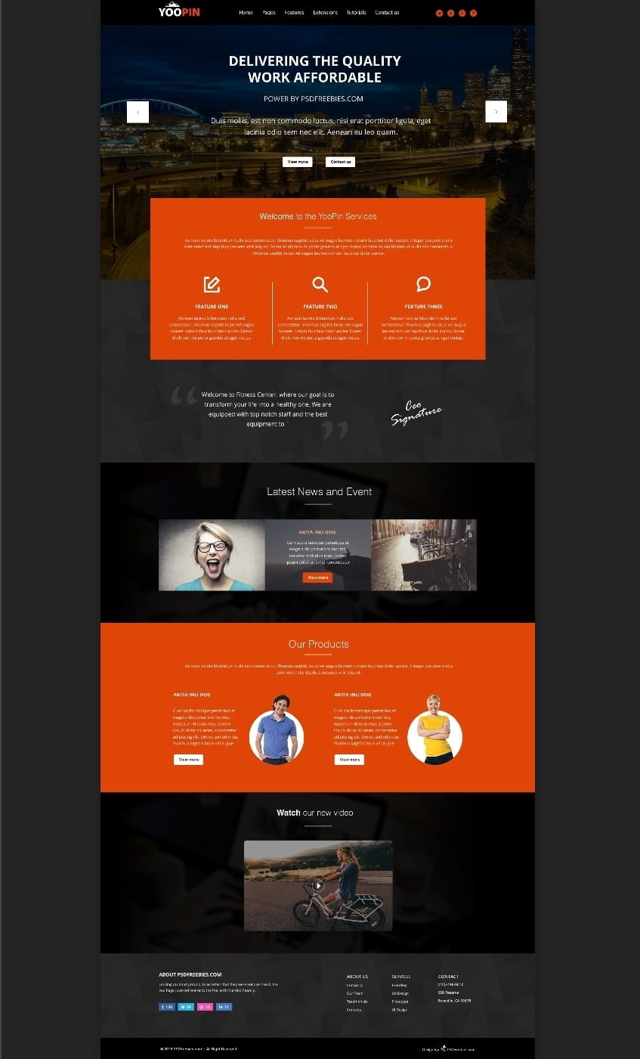

**4.File Structure**

* **Public:-**
  + **index.html: The main HTML file where the React app will be rendered. Contains the root div element (<div id="root"></div>).**
* **Src:-**
  + **assets/: Contains static files such as images and stylesheets.**
    - **images/: Store image files here.**
  + **Styles/: Store CSS files here. You can also use CSS Modules or SASS.**
    - **index.css: Main stylesheet for your project.**
* **components/: Contains all React components.**
* **App.js: The root component of your application.**

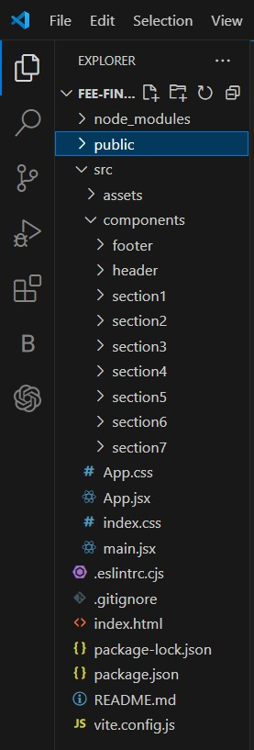

**5.Code:**

**Index.html**

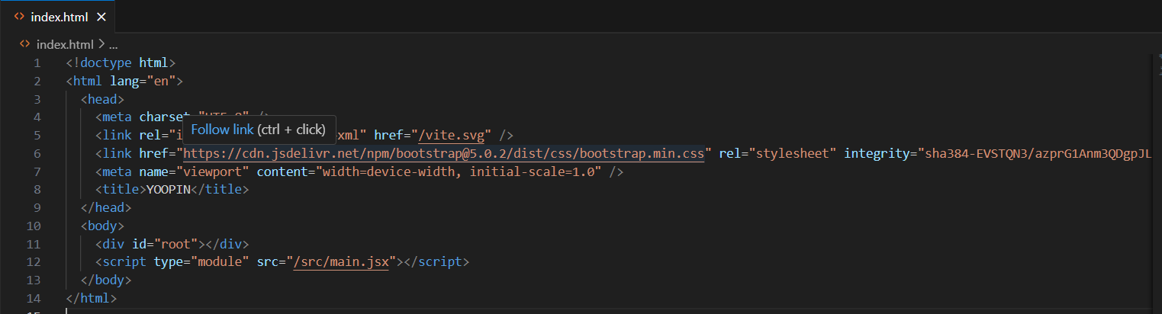

**App.jsx**

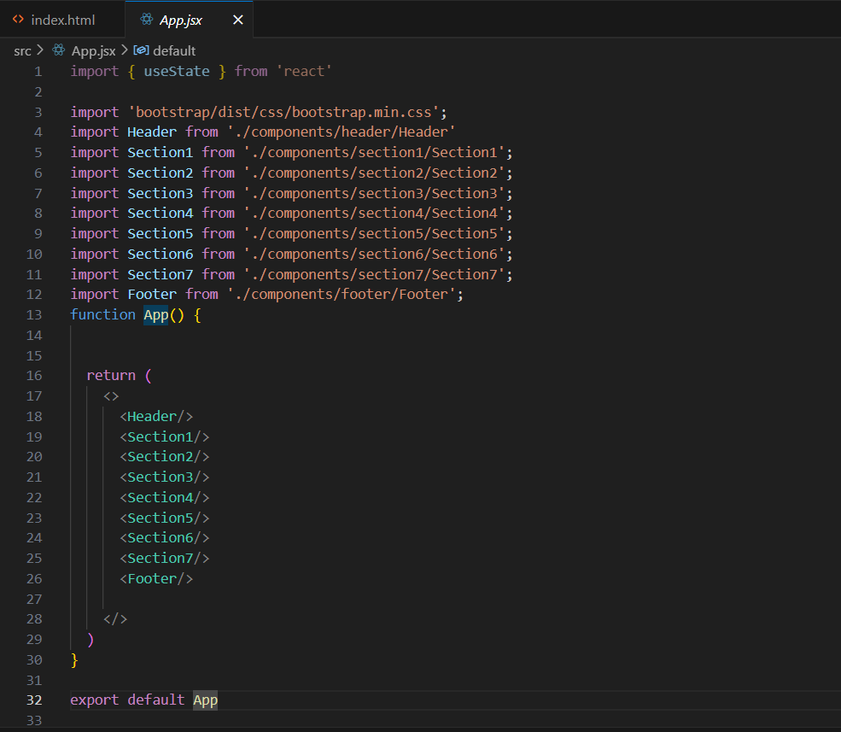

**Main.jsx**

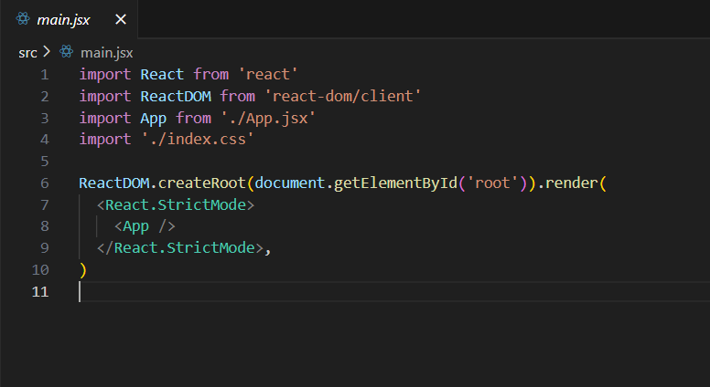

**Components--**

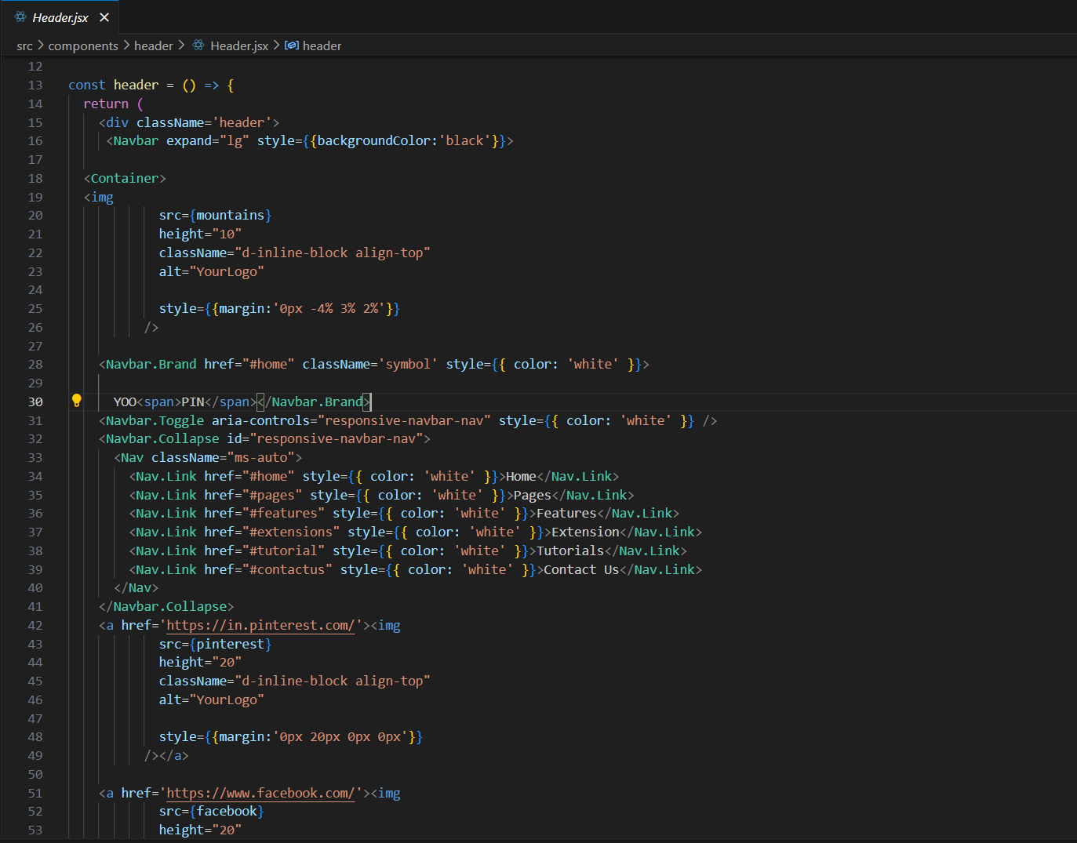

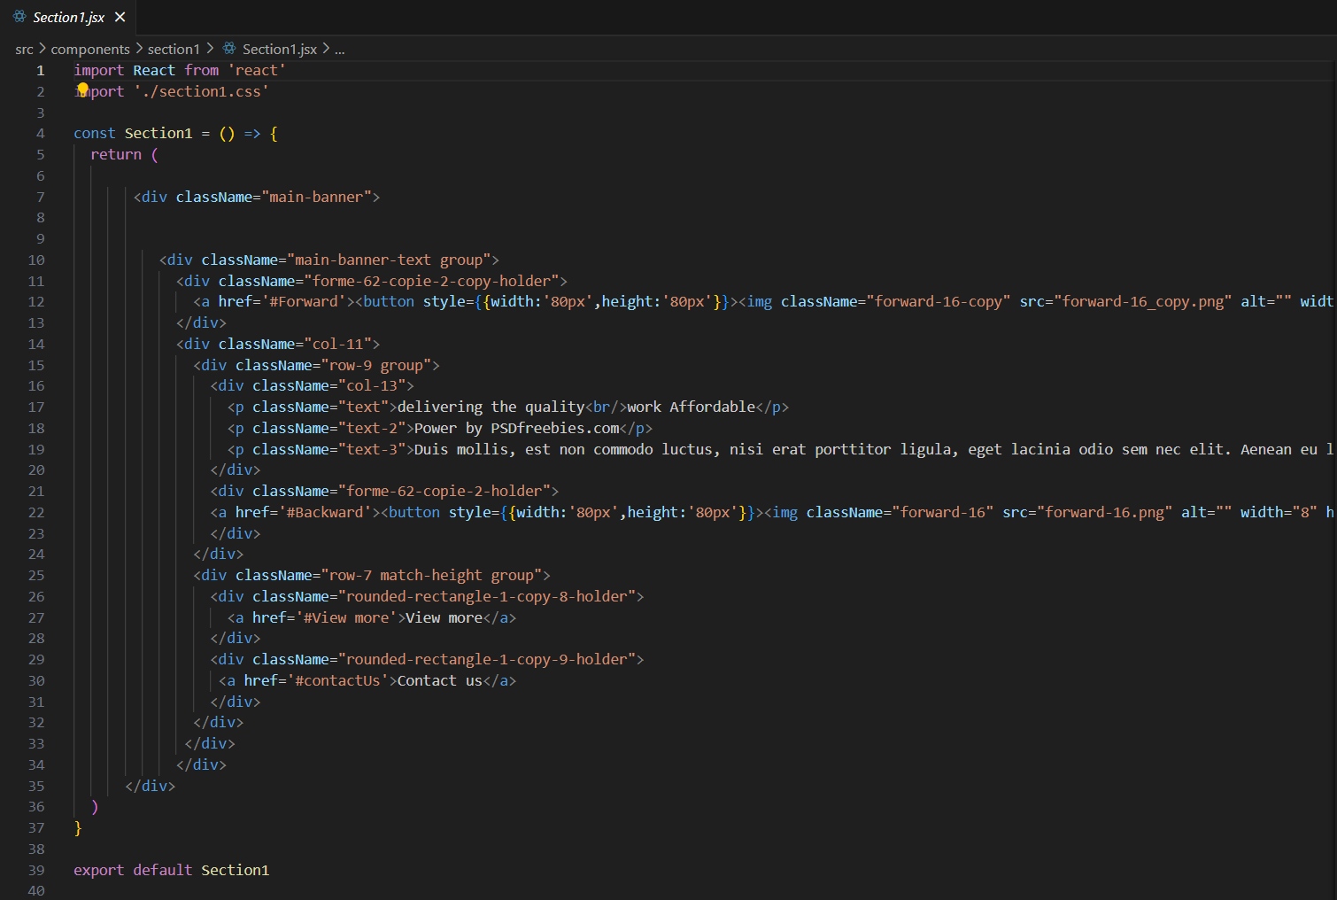

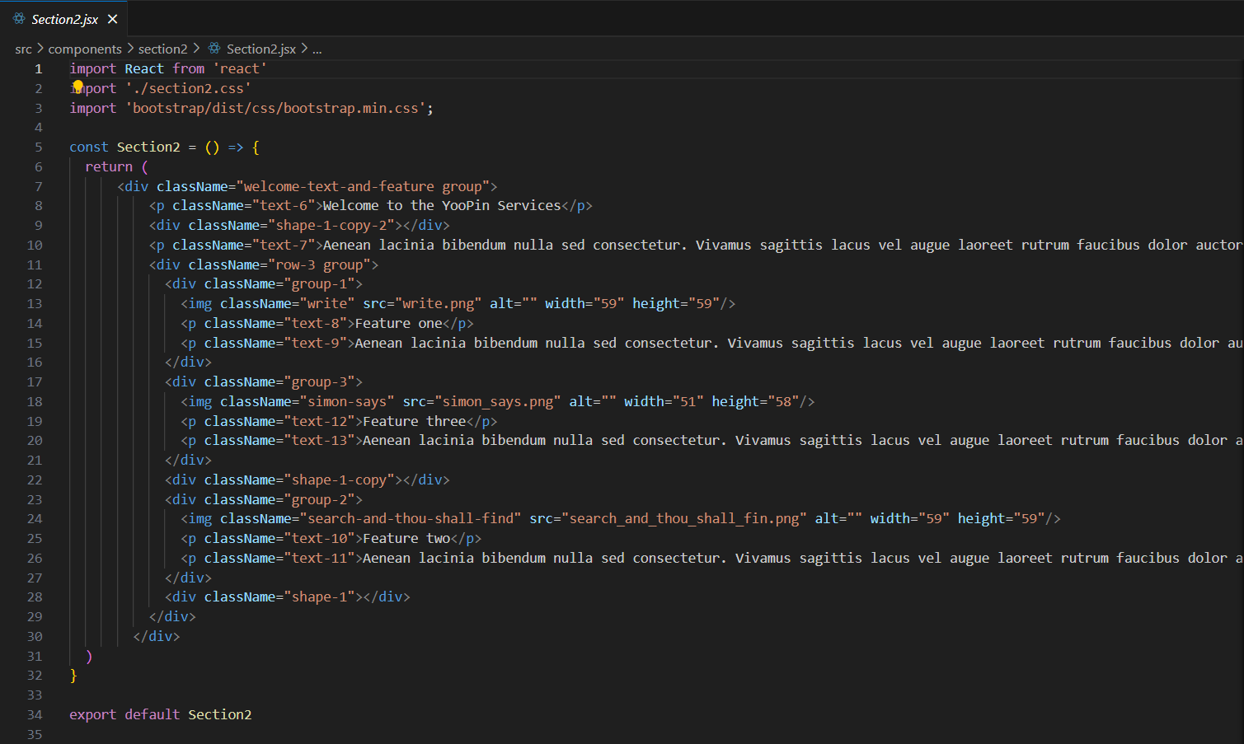

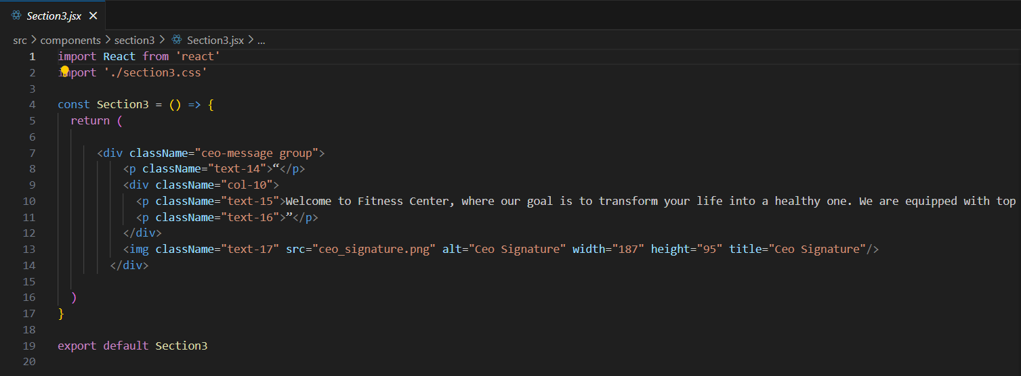

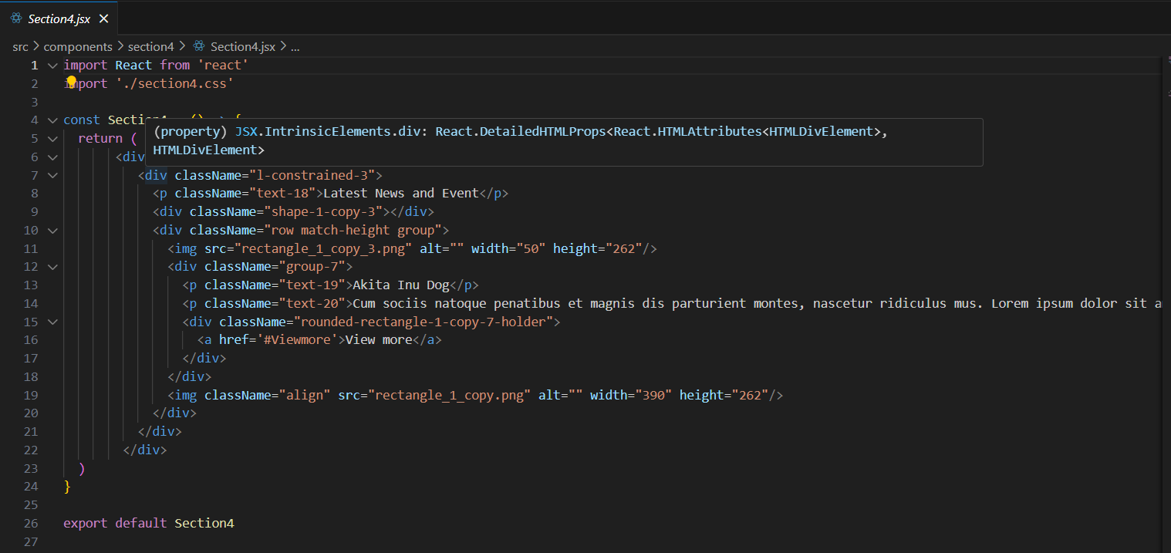

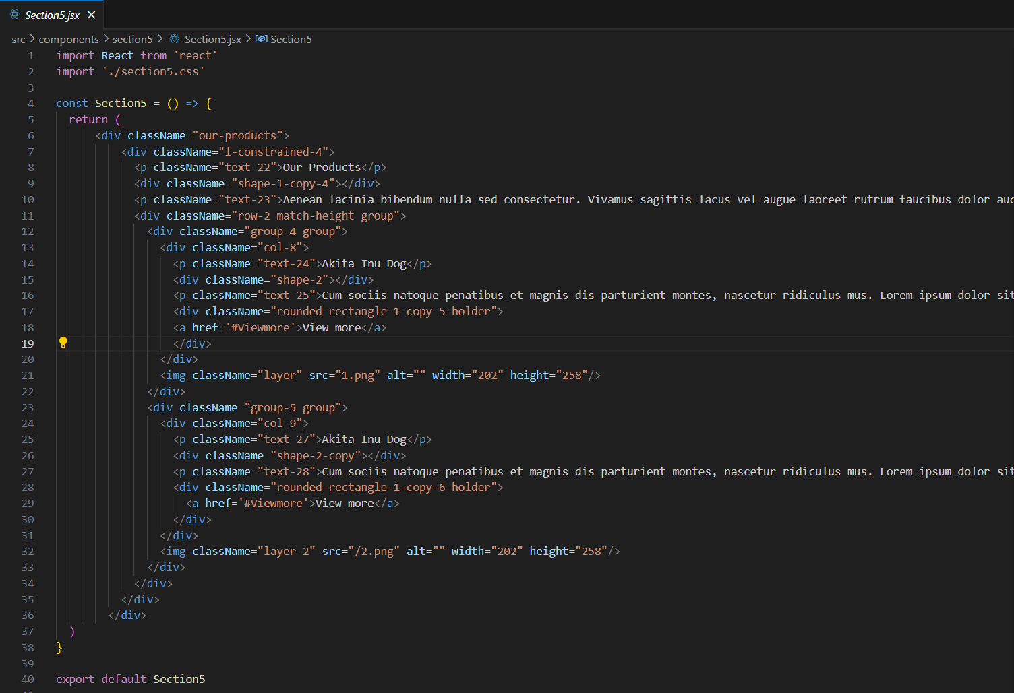

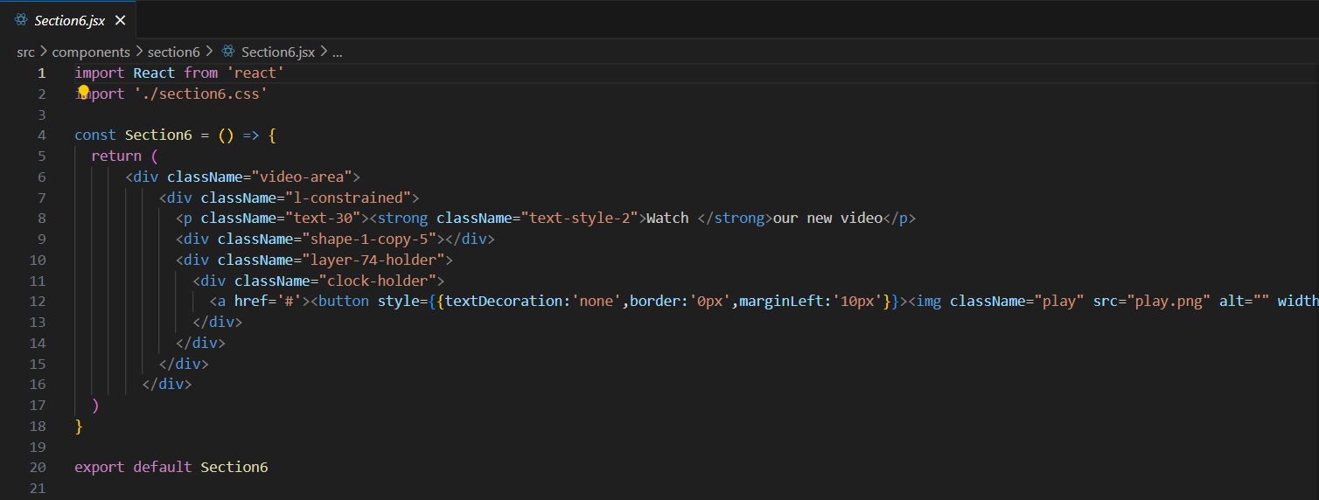

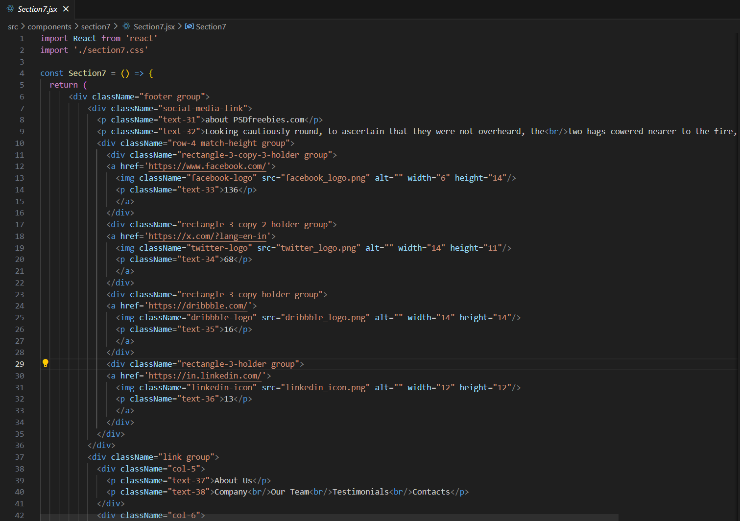

**6.Results:-**

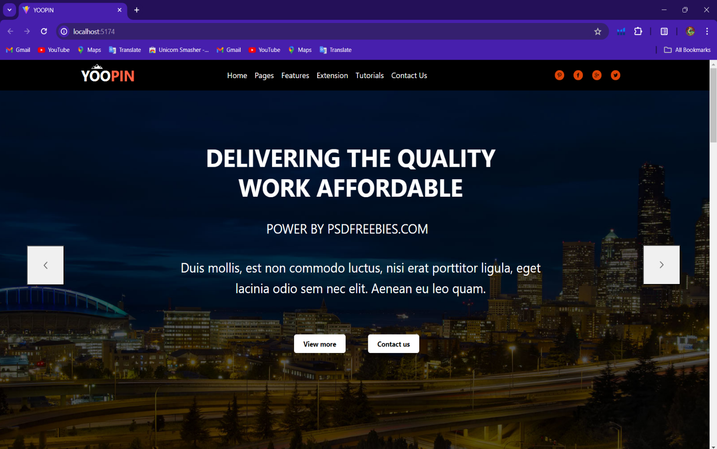

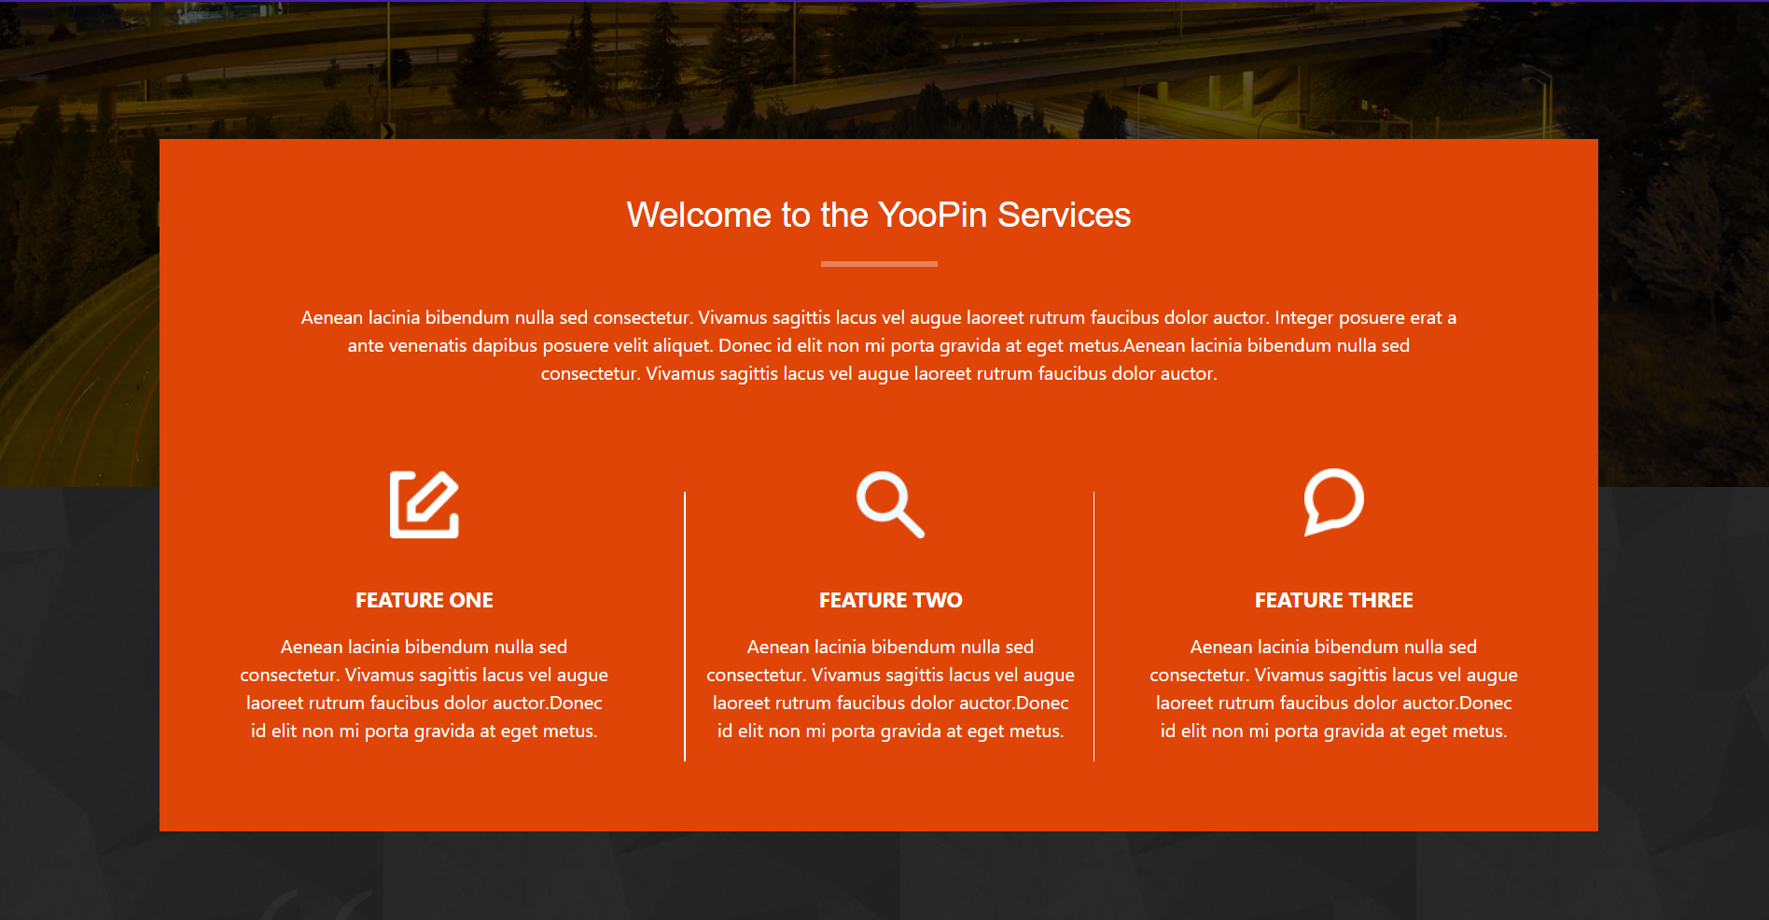



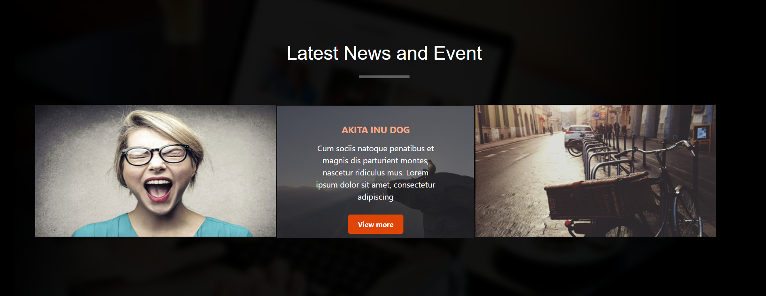

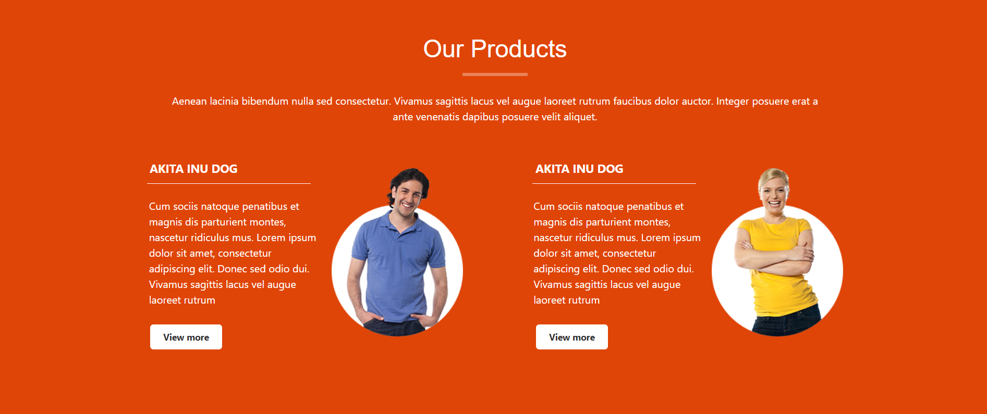

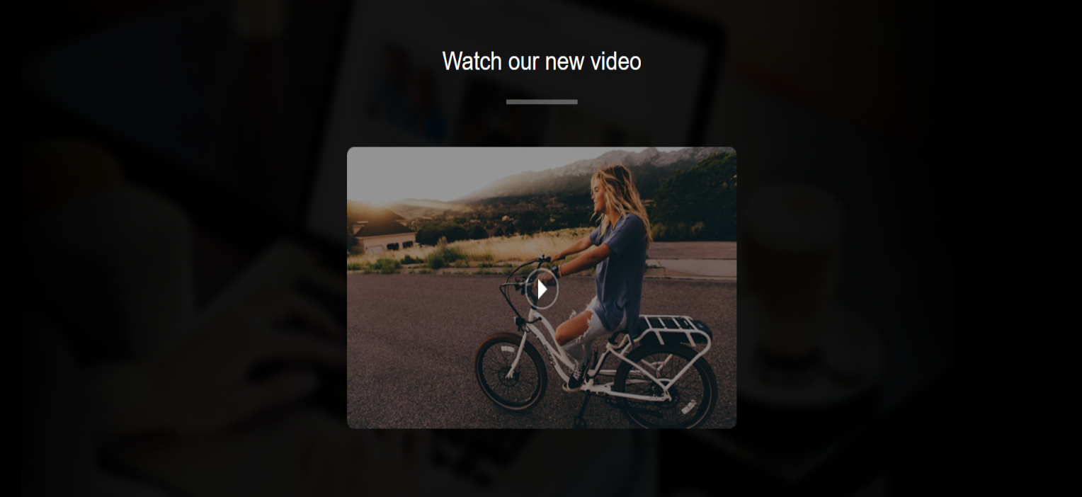

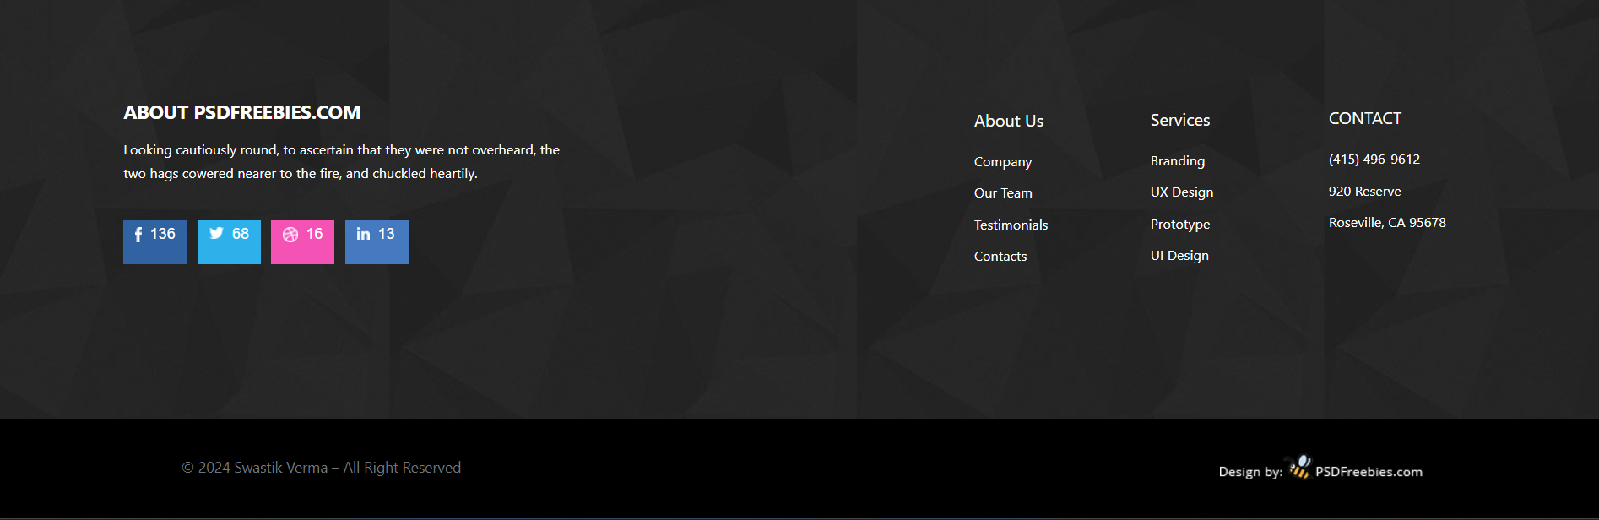

**REFERENCES**

1. [React Bootstrap | React Bootstrap (react-bootstrap.github.io)](https://react-bootstrap.github.io/)
2. <https://react-icons.github.io/react-icons>
3. <https://react.dev/>
4. [www.w3schools.com](http://www.w3schools.com)
5. <https://fonts.google.com>